USN | 1 | M | S
M S RAMAIAH INSTITUTE OF TECHNOLOGY
(AUTONOMOUS INSTITUTE, AFFILIATED TO VTU)
BANGALORE – 560 054
MAKEUP EXAMINATIONS – JULY 2016

Course & Branch | : | B.E. – Electrical & Electronics Engg. | Semester | : | IV
Subject | : | Signals and Systems | Max. Marks | : | 100
Subject Code | : | EE403 | Duration | : | 3 Hrs

Instructions to the Candidates:
- Answer one full question from each unit.

 |  |  | UNIT – I
1. | a) |  | Define signal and system with examples. Give a brief classification of the signals with appropriate diagrams where ever necessary. | CO1 | (06)
 | b) |  | Two signals x(t) and g(t) is shown in the figure1(b). Express the signal x(t) in terms of g (t)  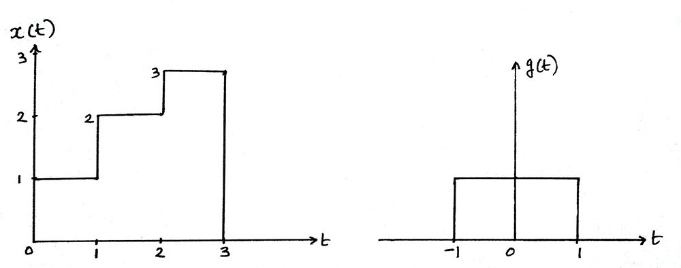  Fig.1(b). | CO1 | (07)
 | c) |  | Given the signal x(t), as shown in figure 1(c ), sketch x(-2t+3) and x(t/2 – 2)  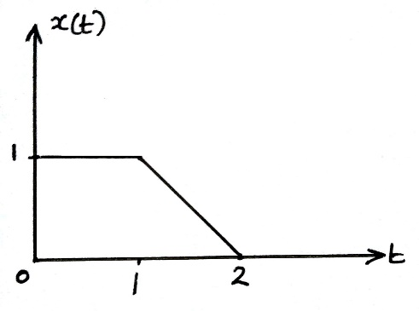  figure 1(c) | CO1 | (07)
2 | a) |  | Determine whether the system y(n)=x(n)+3u(n+1) is  i. Linear ii. Time invariant iii. Causal  iv. Memoryless v. Stable | CO1 | (08)
 | b) |  | Determine whether the signal shown in figure 2(b) is a power signal or energy signal. Justify your answer and further determine its energy or power.  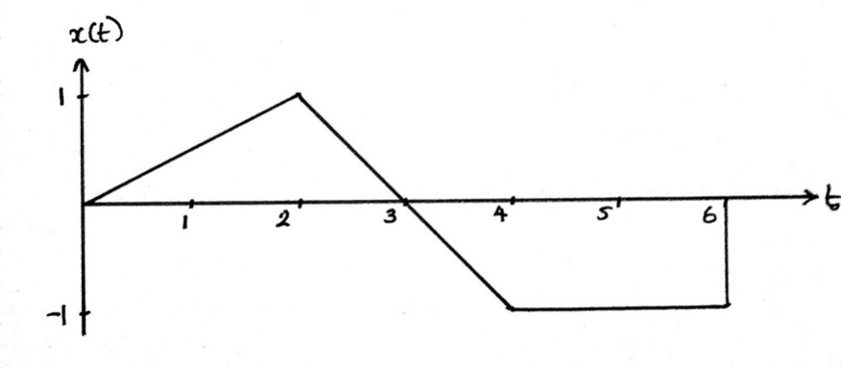  Fig. 2(b) | CO1 | (06)
 | c) |  | Determine and sketch the even and odd parts of the signals shown in the figure2(c)  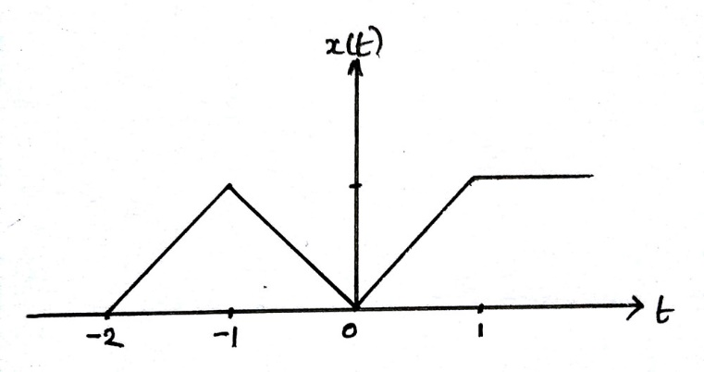  Fig.2(c) | CO1 | (06)
 |  |  | UNIT – II
3. | a) |  | Consider the input signal x(n) and impulse response h(n) given below. Obtain the convolution sum.  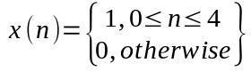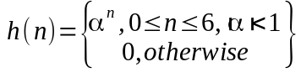 | CO2 | (08)
 | b) |  | Explain the properties of the convolution . | CO2 | (06)
 | c) |  | Find the step response for the system having impulse response  h(t)= e^{-2|t|} | CO2 | (06)
4. | a) |  | Find the convolution integral of x(t) and h(t) and sketch the convolved signal.  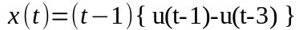and 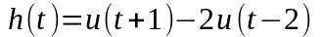 | CO2 | (10)
 | b) |  | Identify whether the system whose impulse response given below is stable, causal and memory less.  i. h(t)=e^{-t} u(t+100) ii. h(t)= e^{-4|t|}  iii. h(n)=2 u(n) – 2 u(n-2) iv. h(n) = ð(n)+sinπn | CO1 | (10)
 |  |  | UNIT – III
5. | a) |  | Draw the direct form I and II implementations of the system represented by the differential equation / difference equation  - 2y(t)+3d²y(t)/dt² = 4x(t) -3dx(t)/dt + d²x(t)/dt²  - y(n) + ¹/₂ (n-1) - y(n-3) = 3 x(n-1) + 2 x(n-2) | CO3 | (10)
 | b) |  | Find the forced response of the system described by difference equation:  y(n)-1/4y(n-1)-1/8y(n-2) = x(n)+ x(n-1) with input x(n)=(1/8)^{n} u(n) | CO3 | (05)
 | c) |  | Find the natural response of the system described by differential equation:  dy(t)/dt+2 y(t) =3x(t) for t>=0 and y(0)=5 | CO3 | (05)
6. | a) |  | Find the total response of the given differential equation  d²y(t)/dt²+5dy(t)/dt + 4y(t) = dx(t)/dt where y(0)=0 and dy(t)/dt/_{t=0}=1 and x(t)= e^{-2t} u(t) | CO3 | (08)
 | b) |  | By converting the differential equation to integral equation draw direct form I and direct from II implementation for the system 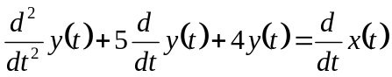 | CO3 | (08)
 | c) |  | List the differences between digital and discrete signal. | CO3 | (04)
 |  |  | UNIT – IV
7. | a) |  | List the properties of DTFS. | CO4 | (06)
 | b) |  | Determine the DTFT of the following signal  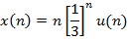 | CO4 | (07)
 | c) |  | Explain Parsevals’ theorem and prove it. | CO4 | (07)
8. | a) |  | State and prove the following properties of DTFT  - Frequency domain multiplication  - Time domain shifting. | CO4 | (10)
 | b) |  | Evaluate the DTFT of the signal and hence draw the magnitude and phase spectra. | CO4 | (10)
 |  |  | UNIT – V
9. |  | a) | Define Z-transform of the discrete time signal x[n].What do you mean by region of convergence. Write the important properties of ROC of the Z-transform. | CO5 | (08)
 |  | b) | Prove the Differentiation and Convolution property of the Z-transform. | CO5 | (08)
 |  | c) | Find the Z-transform of x(n)= cosΩ₀n u(n) | CO5 | (04)
10. |  | a) | Solve the following difference equation using unilateral Z Transform  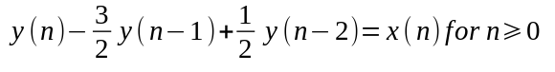  with initial conditions  y(-1)=4, y(-2) = 10 and  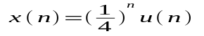 | CO5 | (10)
 |  | b) | An LTI system is represented by the system function 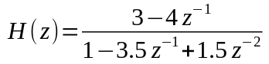.  Specify the ROC of H(z) and determine h(n) for the following conditions.  i. System is stable.  ii. System is causal. | CO5 | (07)
 |  | c) | Find the right sided z transforms of the discrete time signal x(n)=n² | CO5 | (03)

**********************

